DYNAMIC SEAT ALLOCATION SYSTEM

TEAM MEMBERS
- Hasini - 27
- Deekshithulu - 48
- Yagna – 28
- Chaitanya – 49
- Tanveer khan - 40

Introduction / Abstract
- This project creates a simple C program that manages student seating in an examination hall.
- It uses dynamic memory to add or remove students and updates seats automatically.
- Student data is saved in a binary file so it remains available in the next run.
- All actions are also recorded in a text log with timestamps.

Objectives
- To design a seating system that allocates and removes seats efficiently.
- To use dynamic memory (malloc, realloc) for managing student records.
- To store student data permanently using binary file handling.
- To maintain a clear log of all actions using a text file.

Software & Hardware Requirements
- Programming Language: C and Html
- Complier: VS Code / GCC
- Operating System: Windows
- Softwares used Ngrok and Xampp (Apache)

System Design / Flowchart

s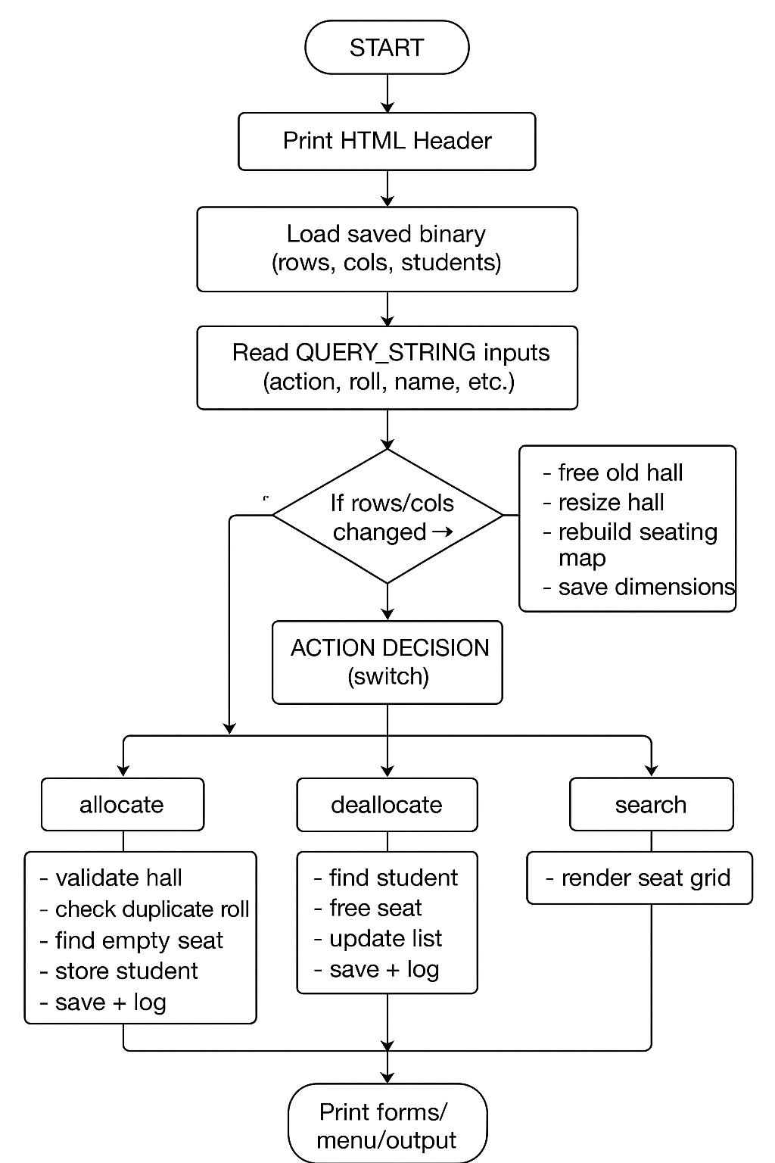

Implementation Details
- log_action() – Records each seat allocation/deallocation with timestamp into a log file.
- save_binary() / load_binary() – Save and reload hall dimensions and student data using a binary file to maintain persistence.
- ensure_hall_allocated() / rebuild_hall_map() – Create the seating grid and rebuild the seat layout whenever rows/columns change.
- allocate_random() – Allocates the next available seat to a student and updates records.
- deallocate_seat() – Removes a student from the hall and updates the seat map and saved data.
- find_student() – Searches for a student in the student list using roll number.
- reset_system() – Clears all stored data when corruption or errors are detected.
- main() – Loads saved data, reads user queries (GET parameters), performs the appropriate action, updates seat data, and renders the full HTML page.

- Ngrok used for host a local webpage to gobal (world wide) webpage
- Xampp (Apache) used to create a local webpage from the .cgi file created from the linked file of c and html
- Here GCC Compiler is used to make .c to .cgi file

Source Code File:
https://github.com/HasiniL2780/C-Project/blob/main/Dynamic_Seat_Allocation.c

Output File:
https://drive.google.com/drive/folders/11SH-Cx5fwYnPWwGvIvNsp38rSrpzGu3L?usp=drive_link

- External Access Link : https://irremovably-unjuicy-felicity.ngrok-free.dev/cgi-bin/dsfw.cgi
It is a publicly accessible Ngrok endpoint that securely tunnels our local CGI application to the internet for external access.”

Results / Output Summary
This program generates a web-based seat allocation system that allows users to allocate, deallocate, search, and view student seating inside a hall. It displays the seat layout, stores student data, logs all actions, and preserves data even after closing (using binary files). The output appears as a HTML page in the browser.
Example Input and Output :
If the user wants to Allocate a seat -
Input:
Action: allocate
Rows: 5
Cols: 10
Roll: 103
Name: Yagna
Output:
Allocated Yagna(101) at (0, 2) .

Conclusion
The team gained hands-on experience with dynamic memory allocation, file handling, and managing data structures in C. We also learned how to design a modular program and maintain data persistence using binary files.
In the future, the system can be improved by adding error-proof input handling, a graphical interface, and support for multiple halls or seat-allocation strategies.

